***PROJECT REPORT TEMPLATE***

**1 Introduction**

**1.1 Overview**

India is the world`s third largest producer and third larger consumer of electricity. The national electric grid in India has an installed capacity of 370.106 GW as of 31 March 2020. Renewable power plants, which also include large hydroelectric plants, constitute 35.86% of India total installed capacity. In 2015-16, electric energy consumption in agriculture was recorded as being the highest worldwide. Analyzing Electricity Consumption in India from Jan 2019 till 5th December 2020. This dataset contains a record of Electricity Consumption in each states of India, here we are going to analyze State wise, Region wise and Overall Electricity consumption in India.

**1.2 Purpose**

Electricity consumption is the actual energy demand made on existing electricity supply for transportation, residential, industrial, commercial and other miscellaneous purposes. Heating and cooling our homes, lighting office buildings, driving cars and moving freight, and manufacturing the products we rely on in our daily lives are all functions that require electricity.

**2. Problem definition & design thinking**

**2.1 Empathy map**

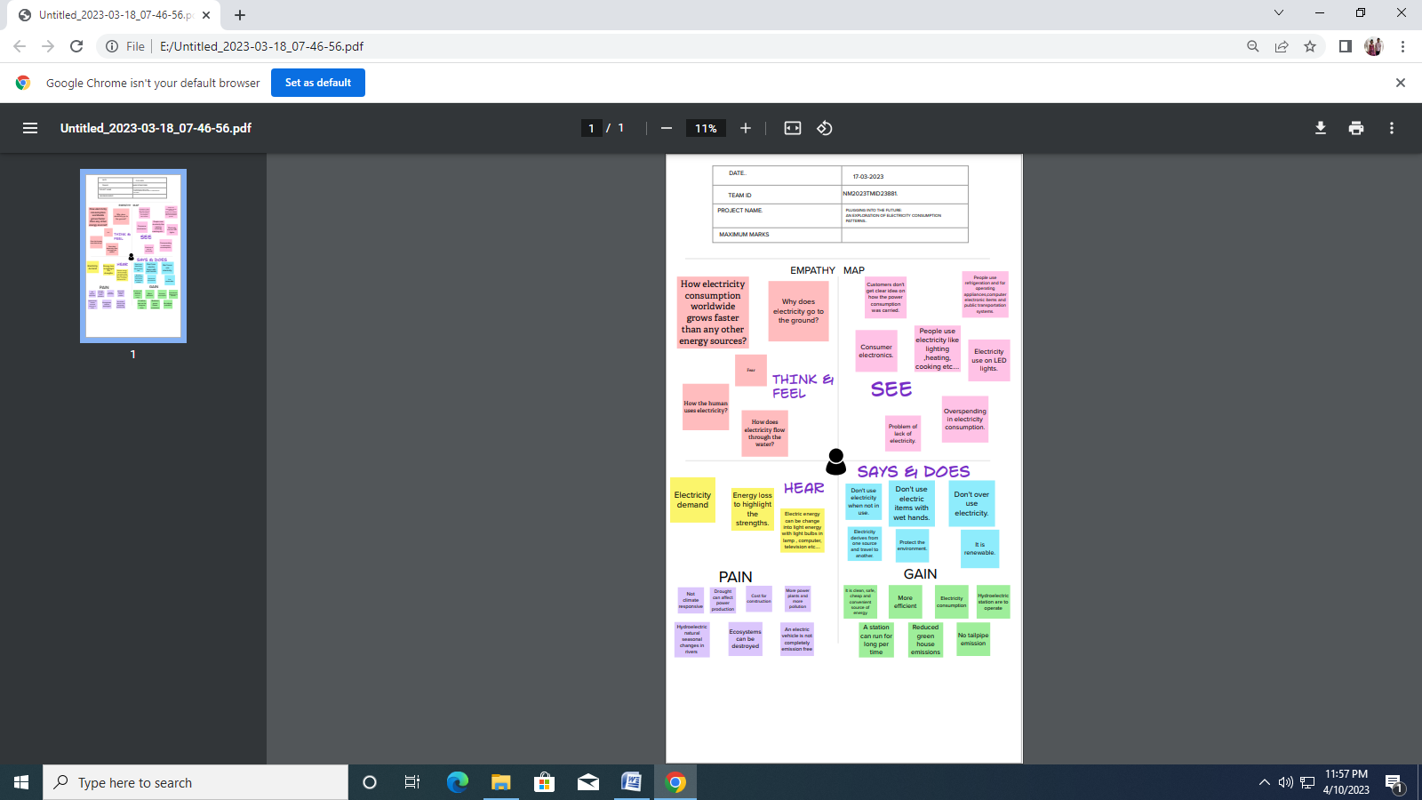

**2.2 Ideation & Brain storming map**

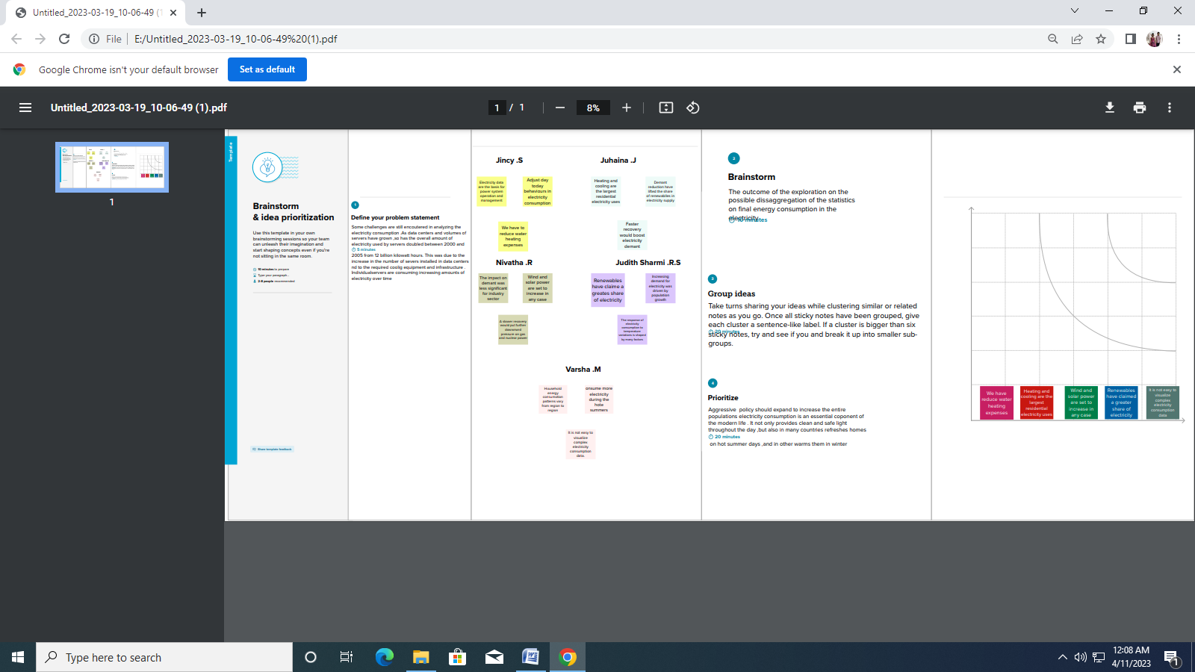

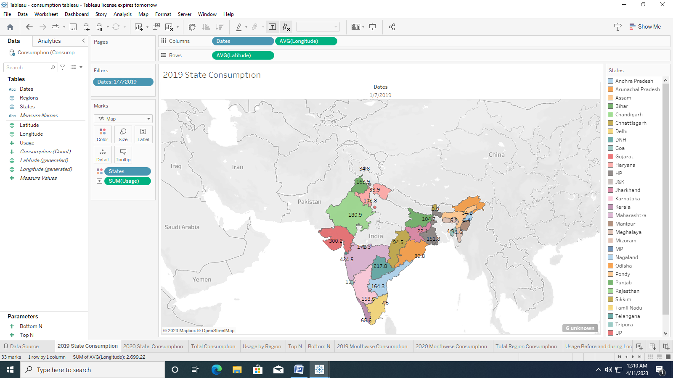

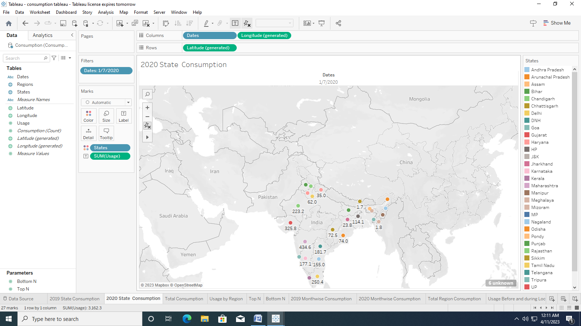

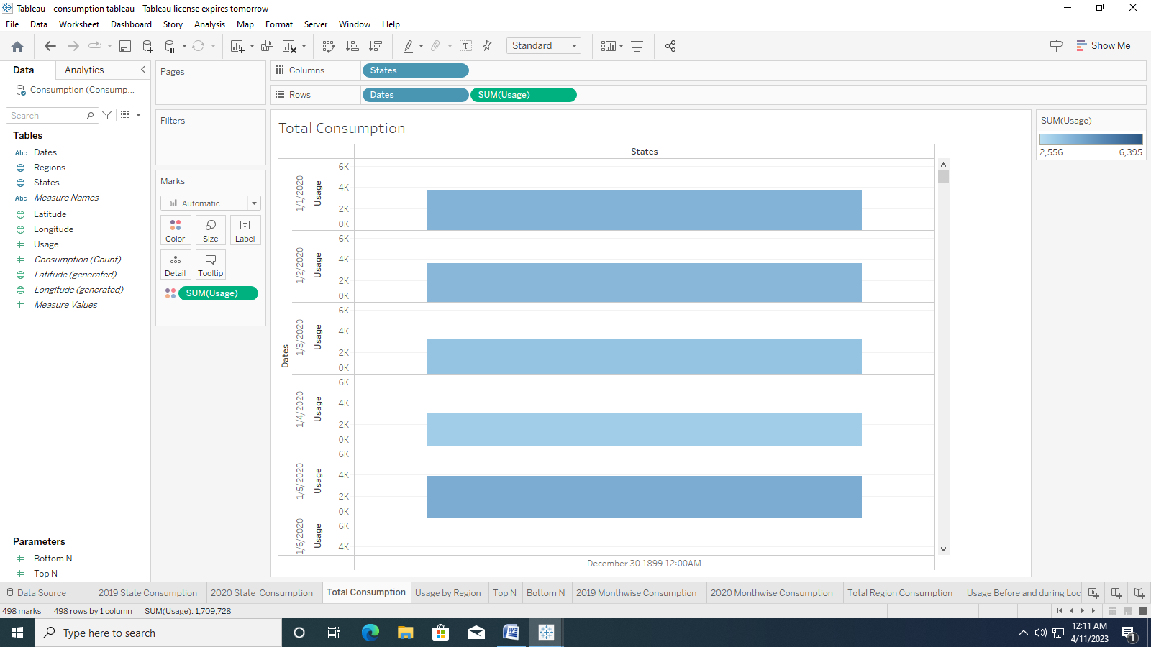

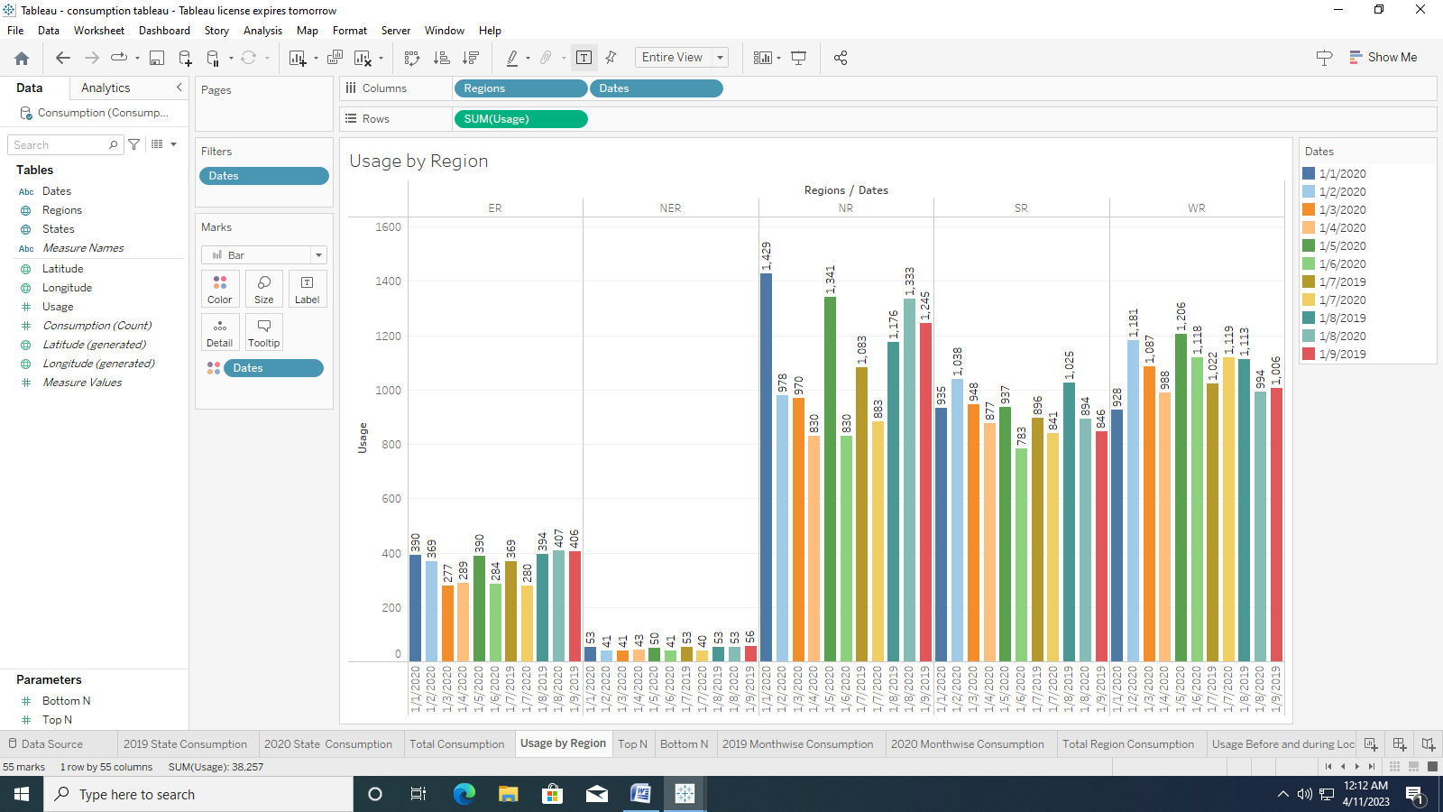

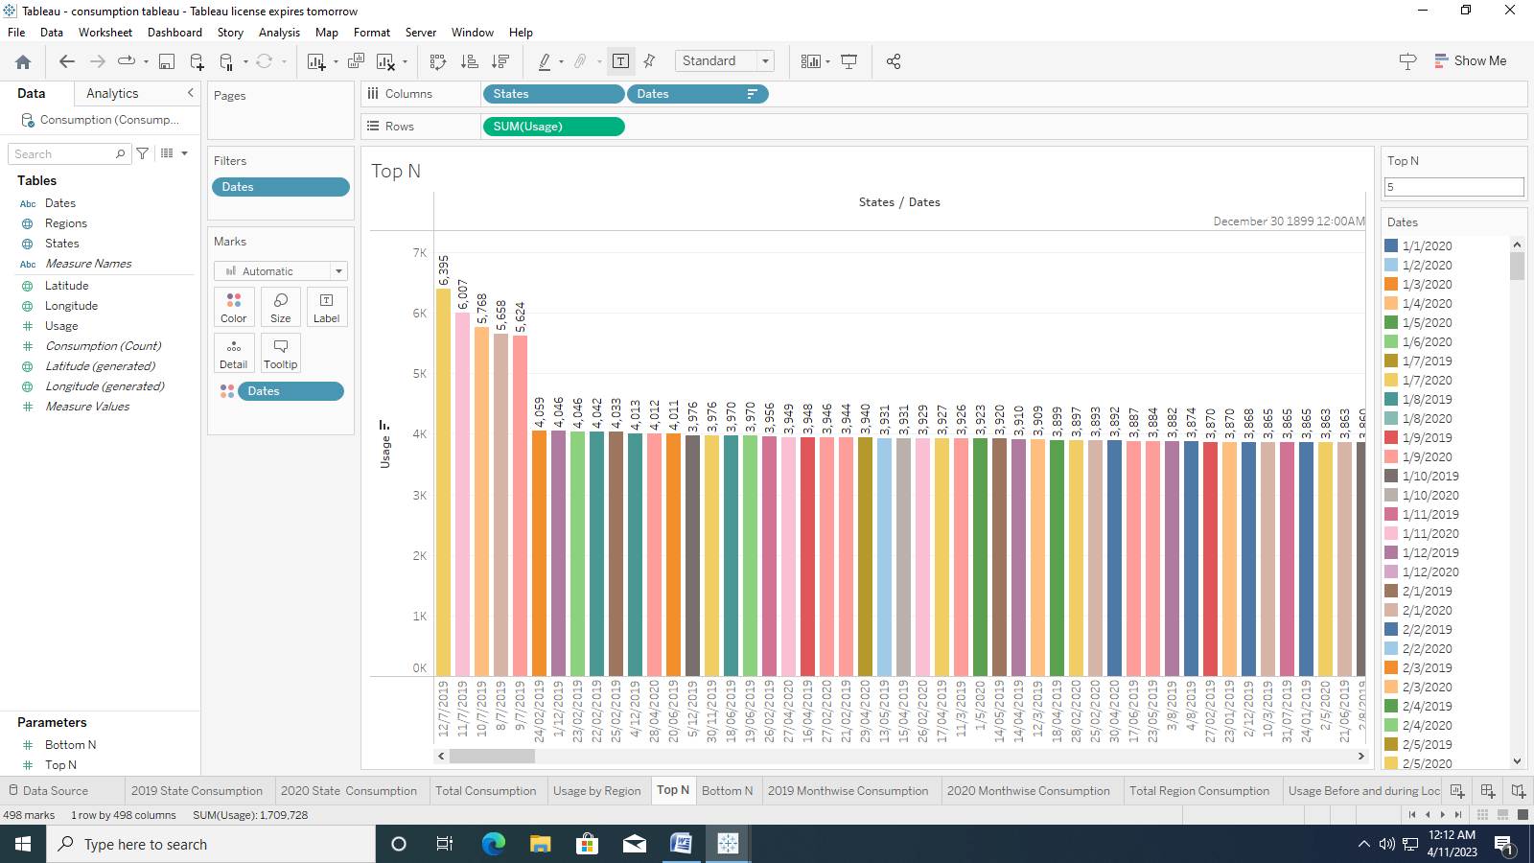

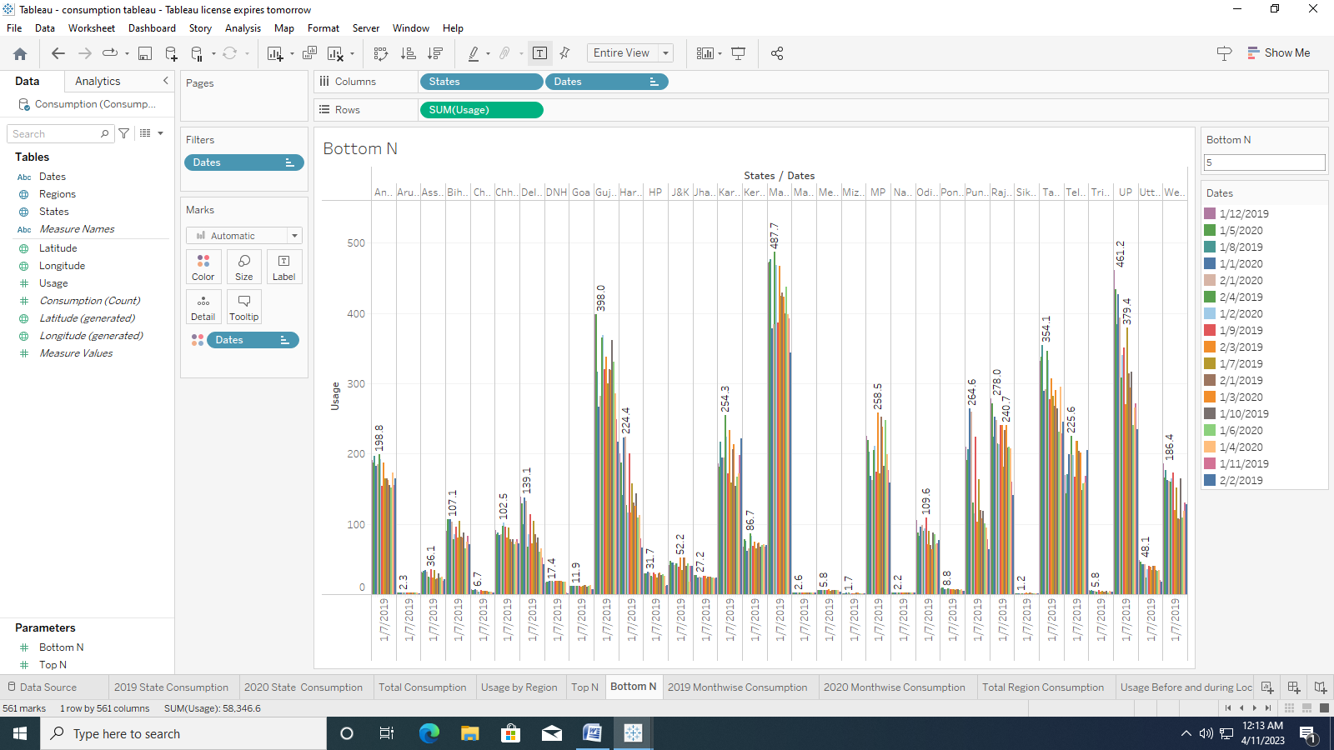

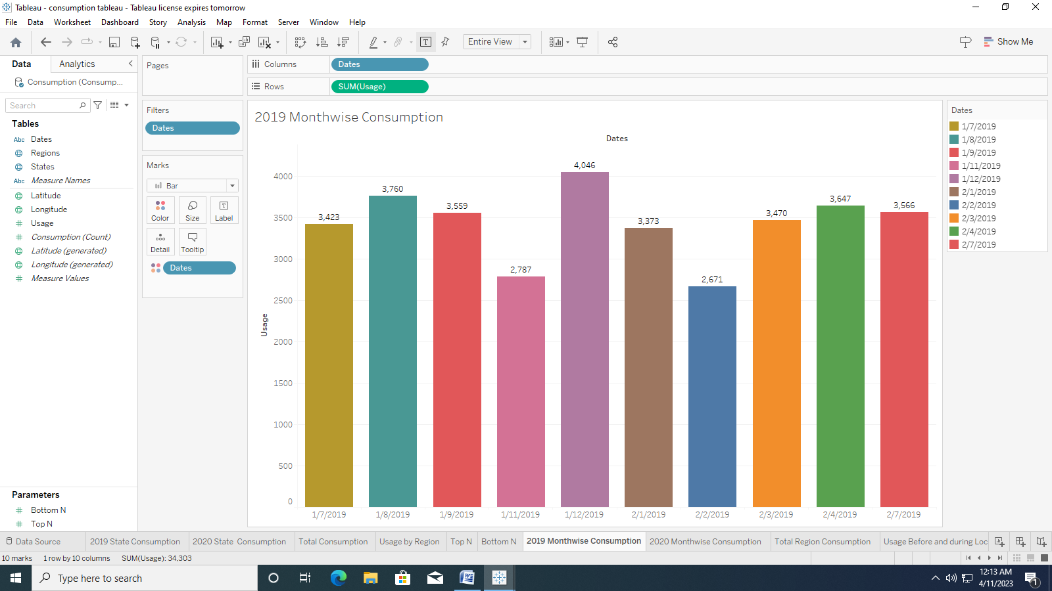

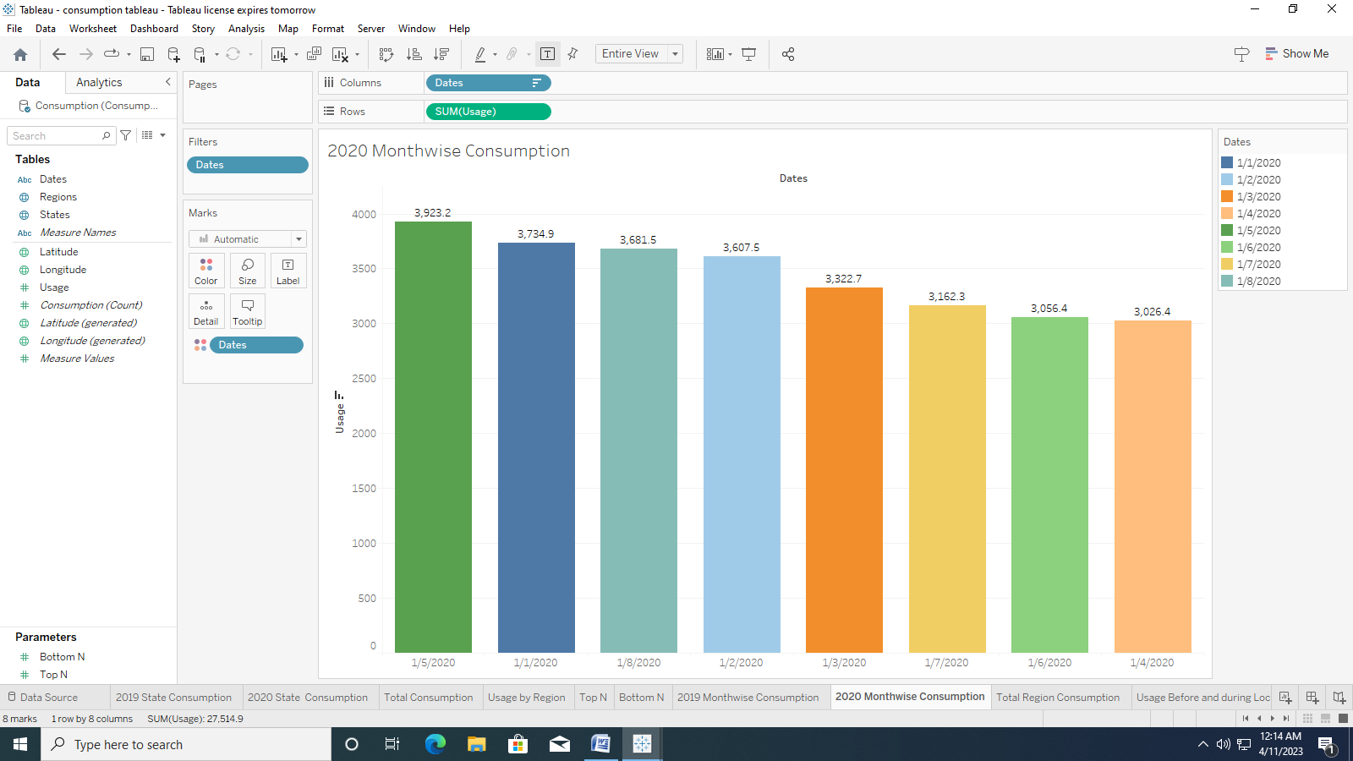

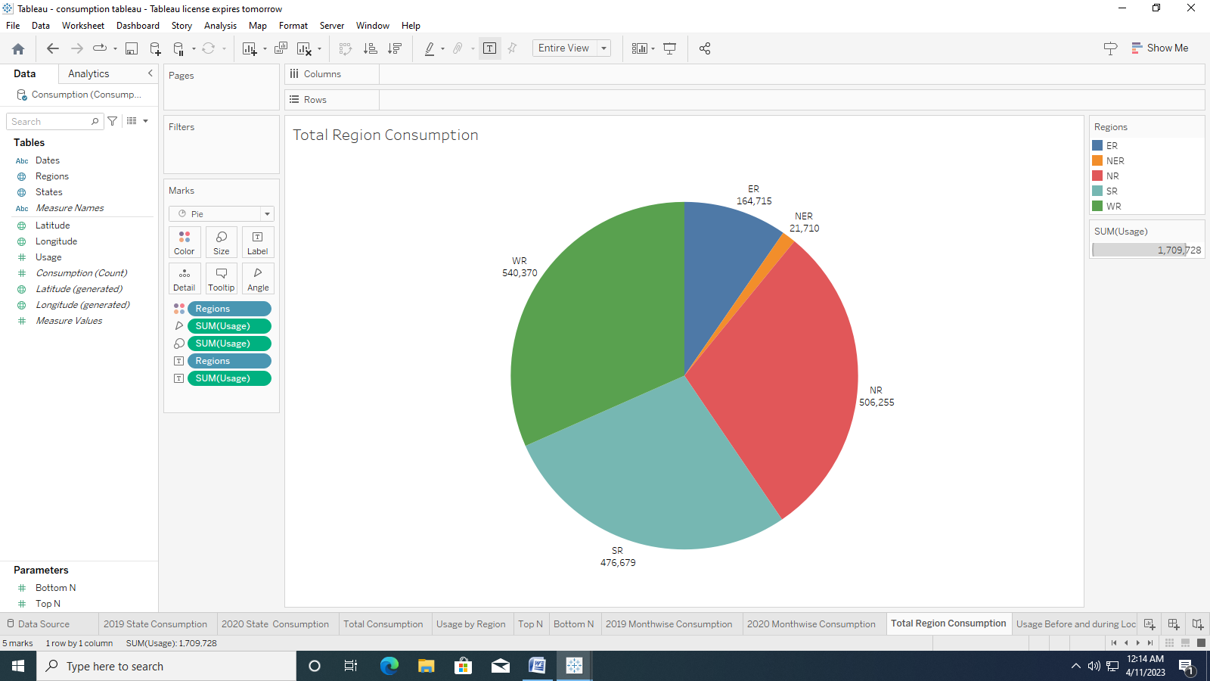

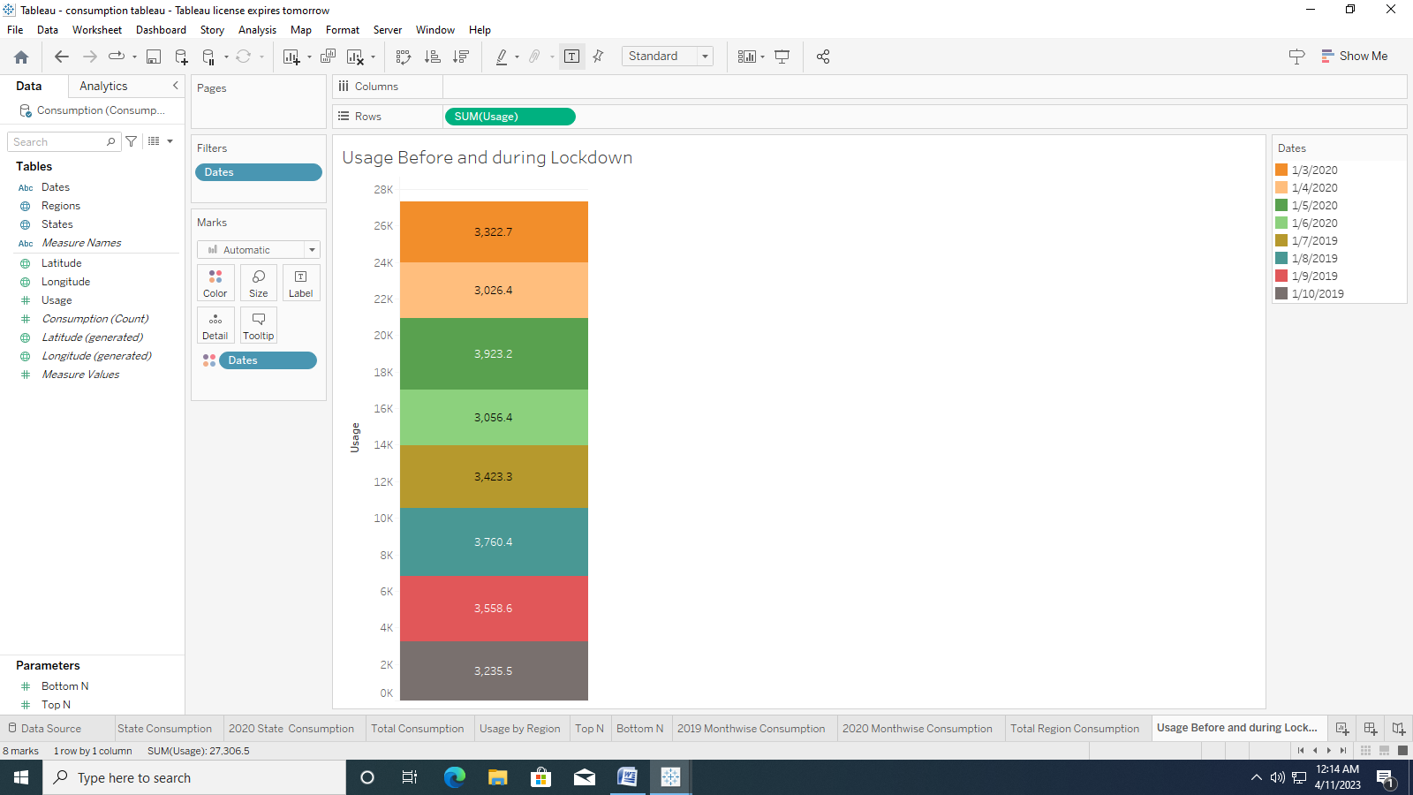

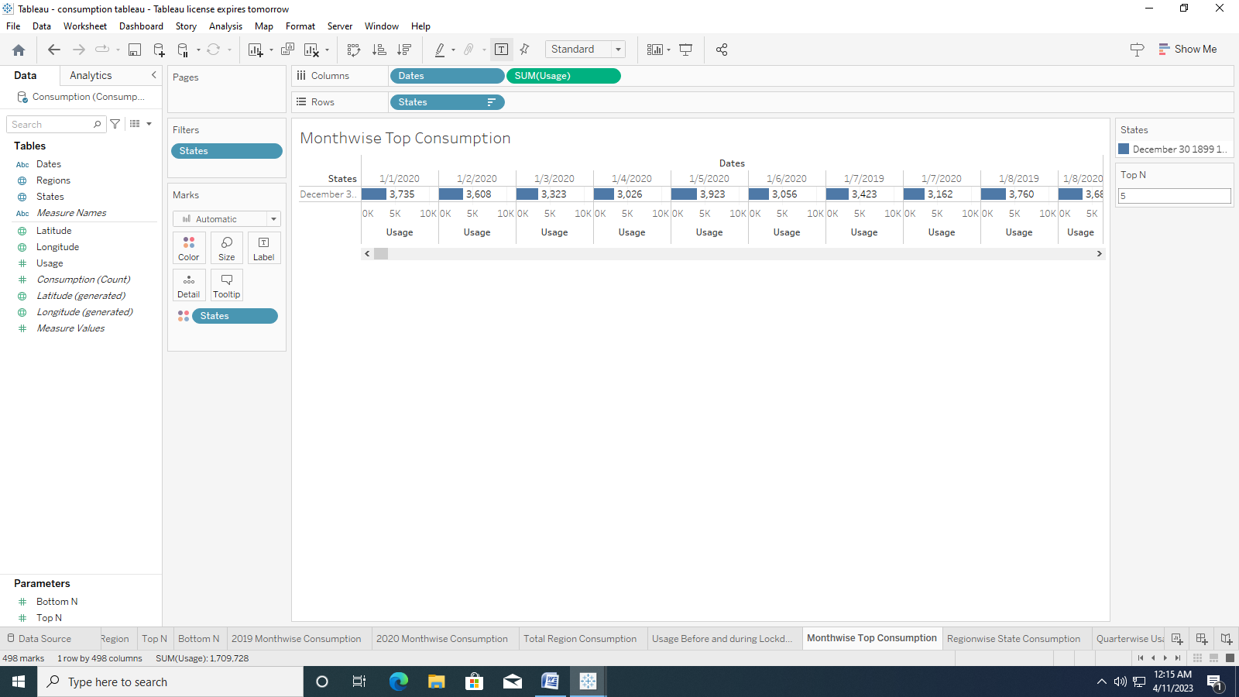

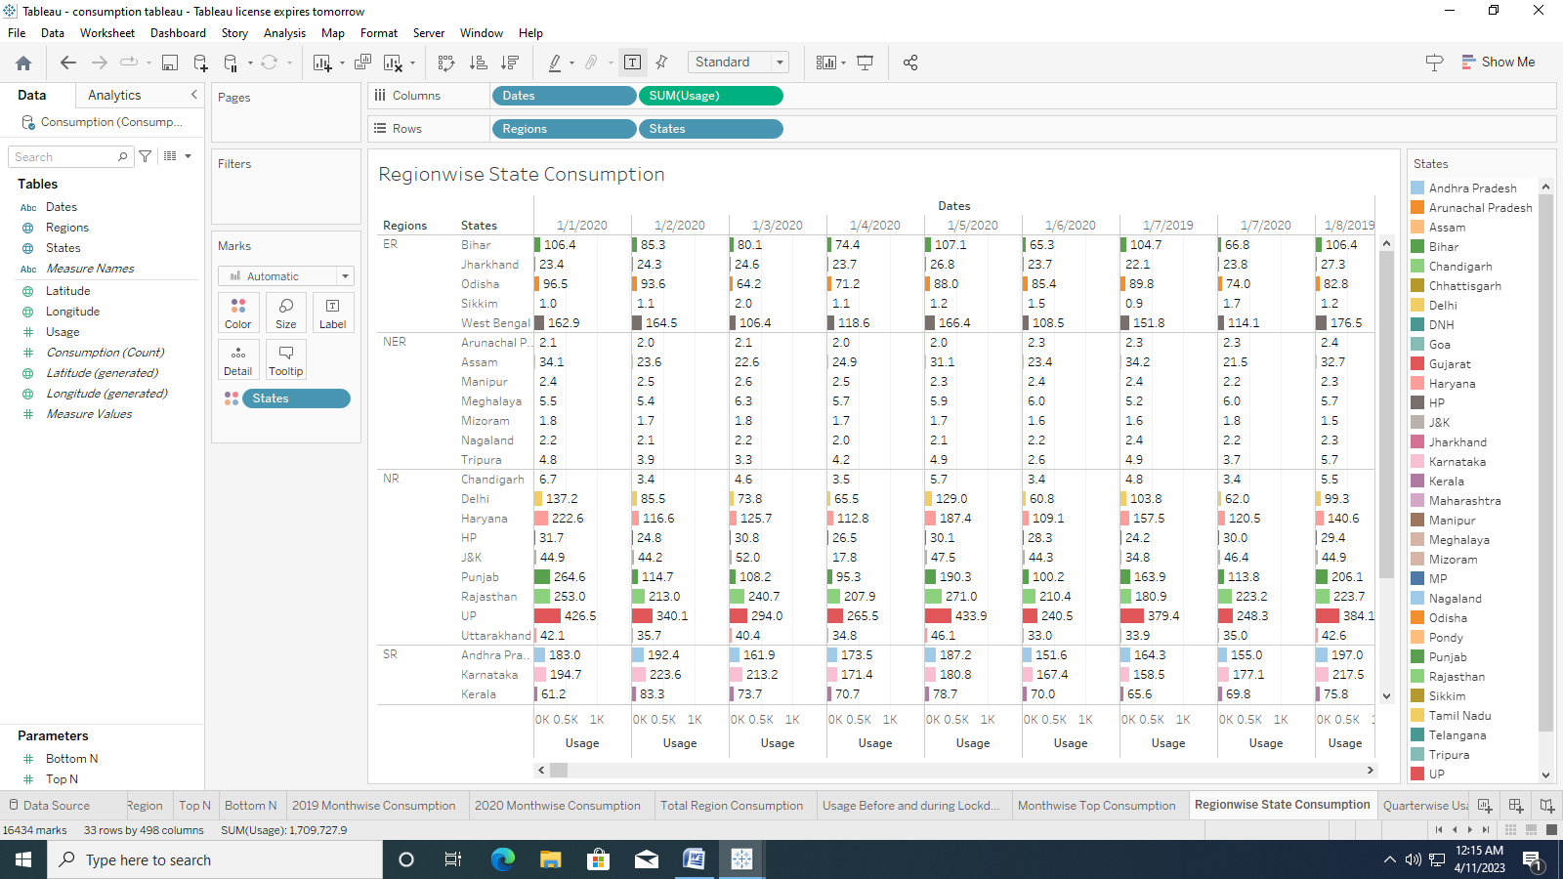

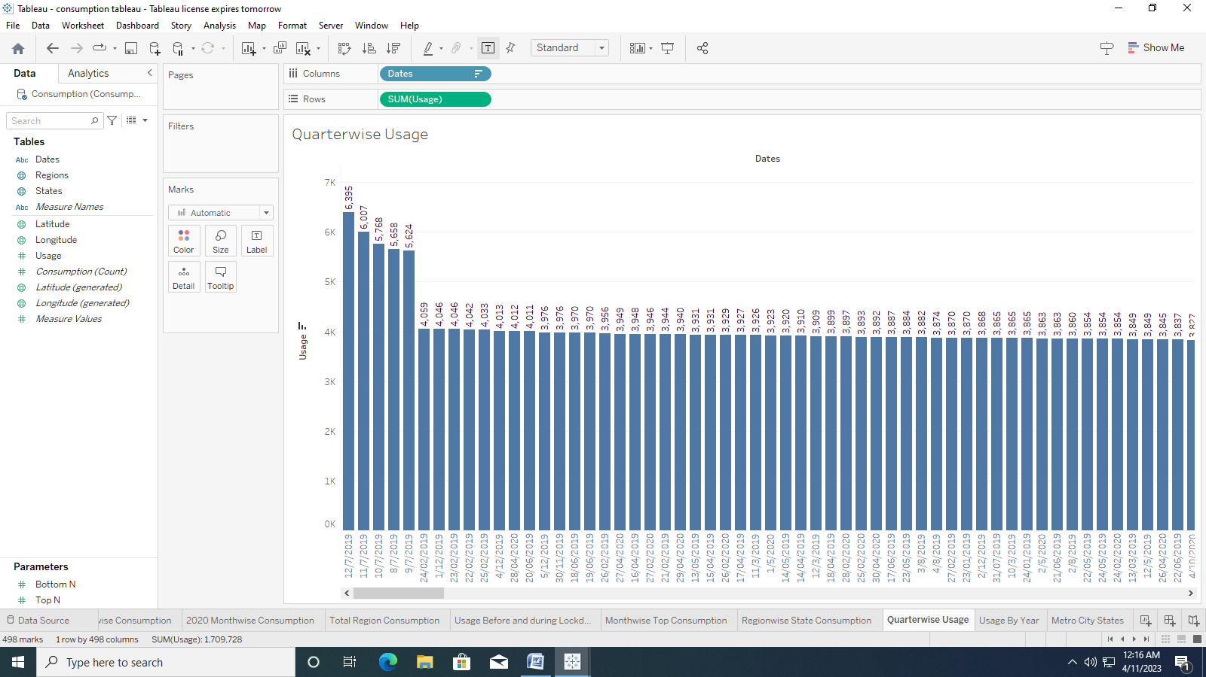

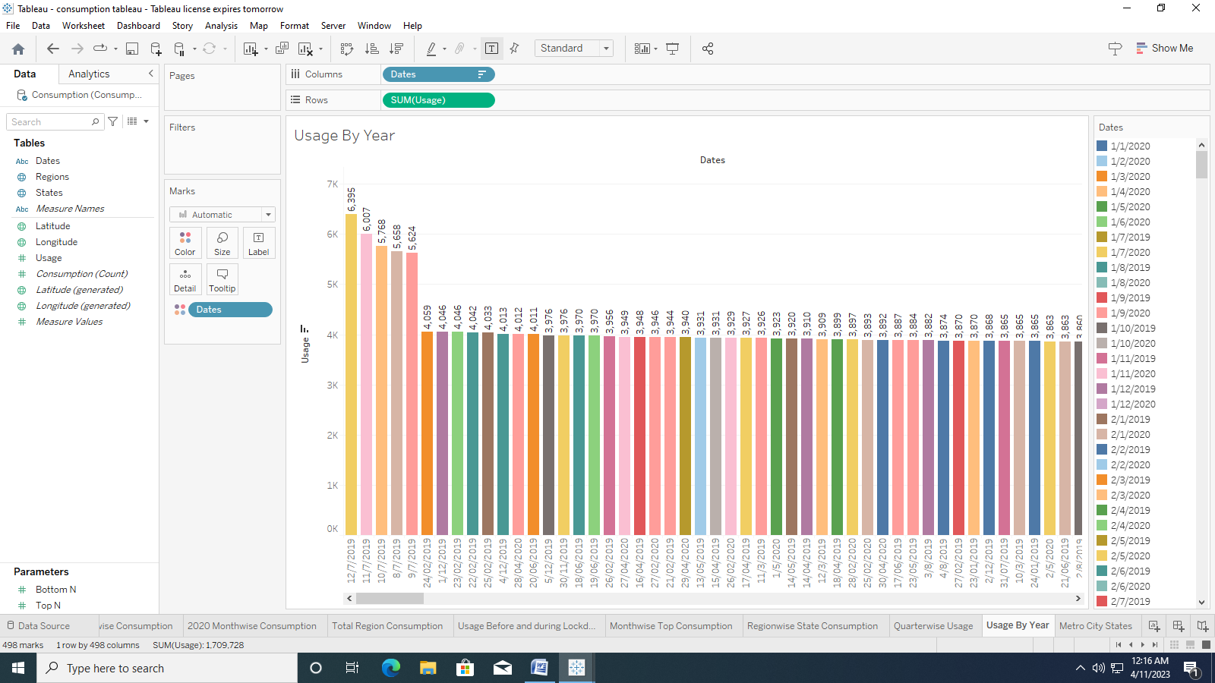

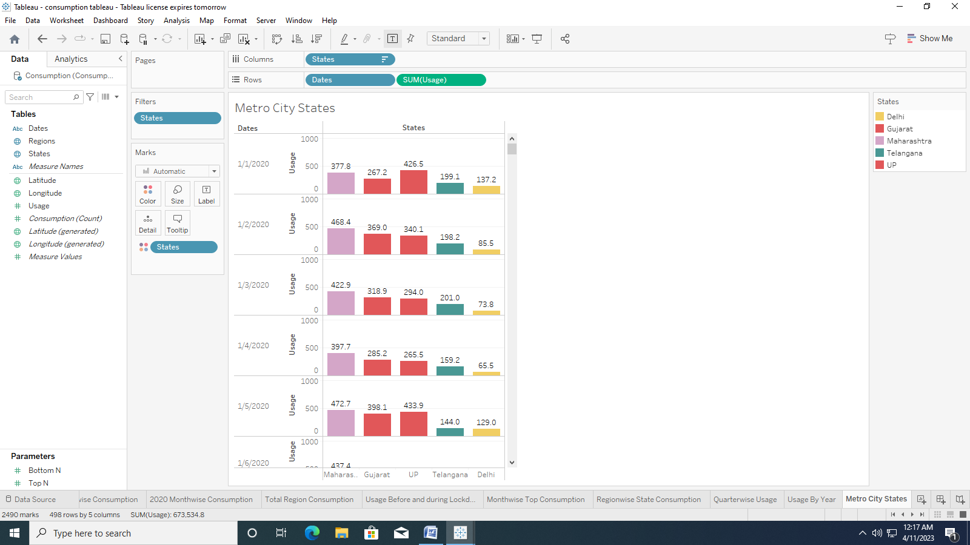

**Dashboard 1**

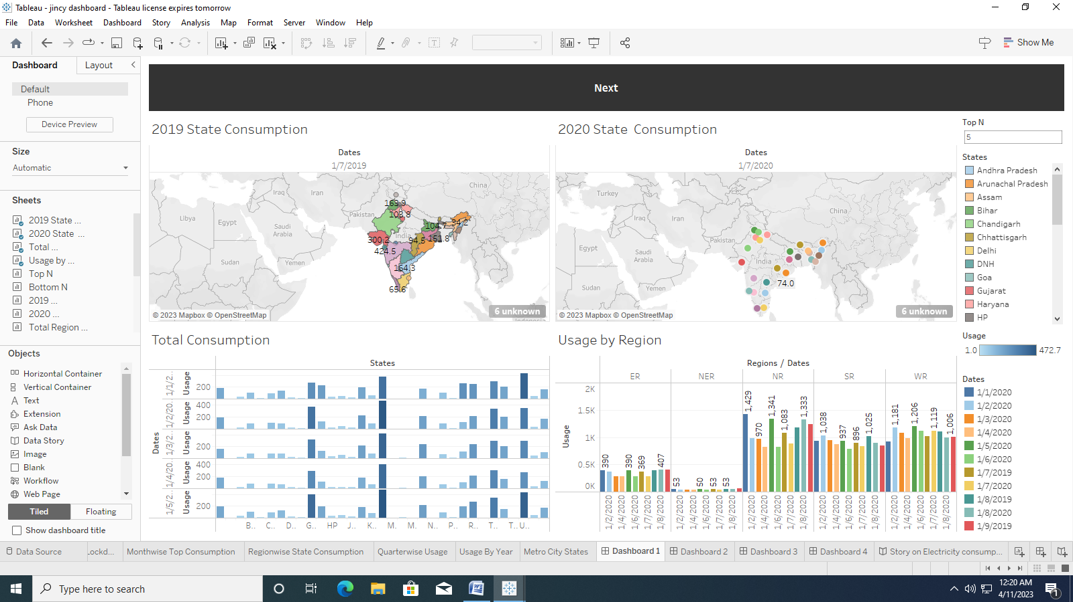

**Dashboard 2**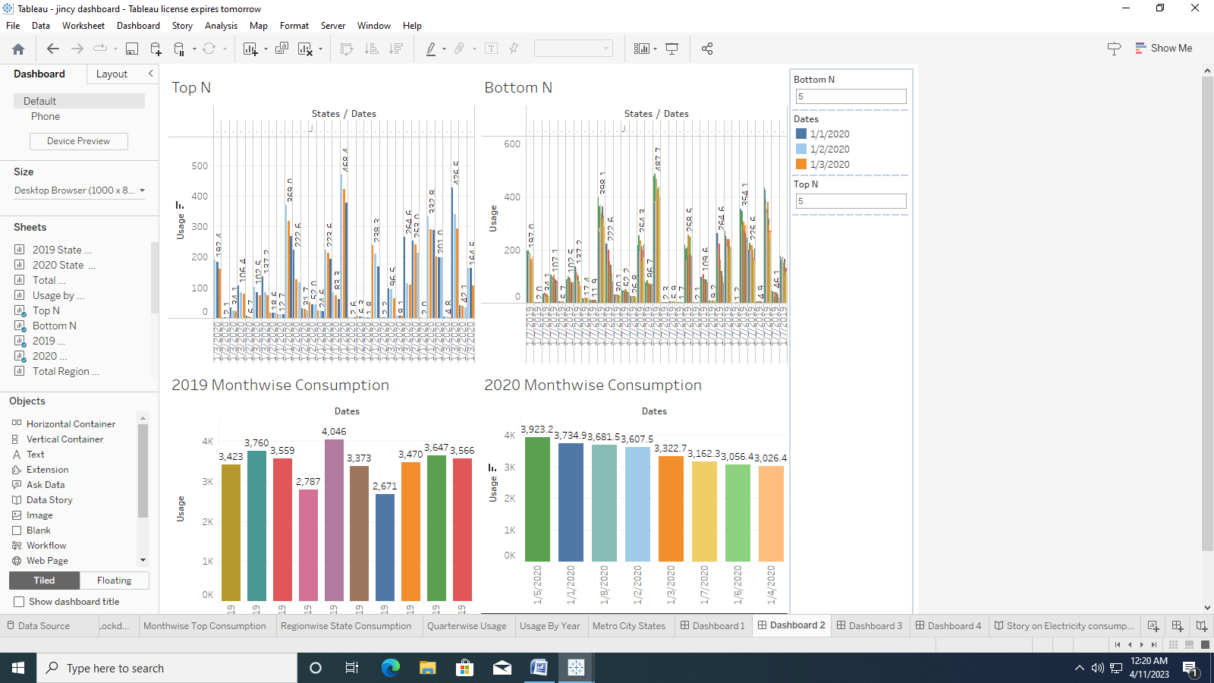

**Dashboard 3**

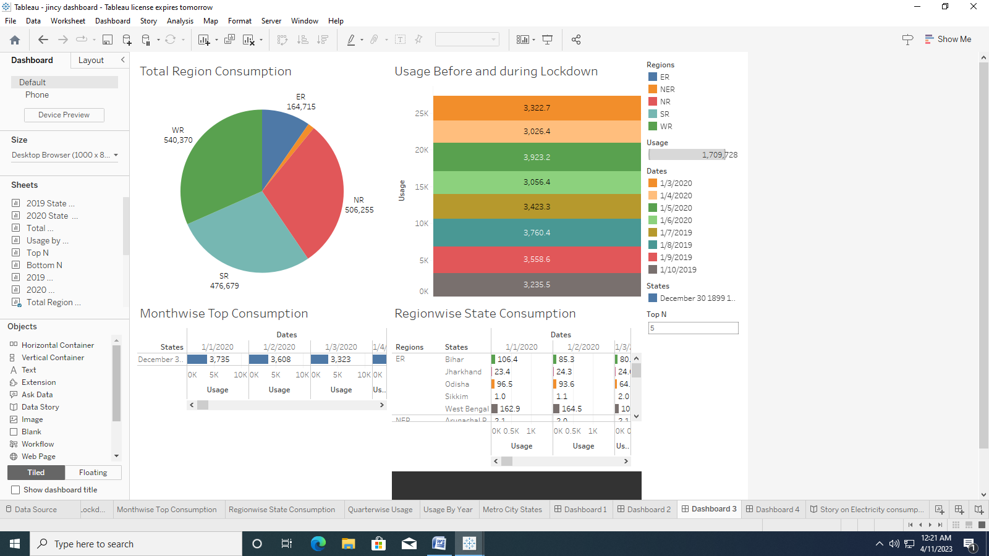

**Dashboard 4**

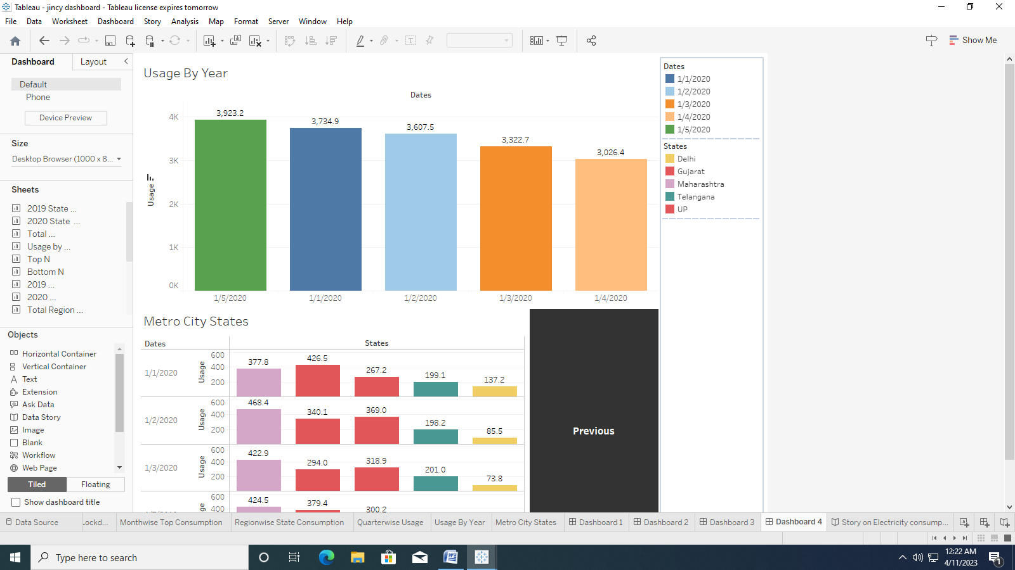

**Story**

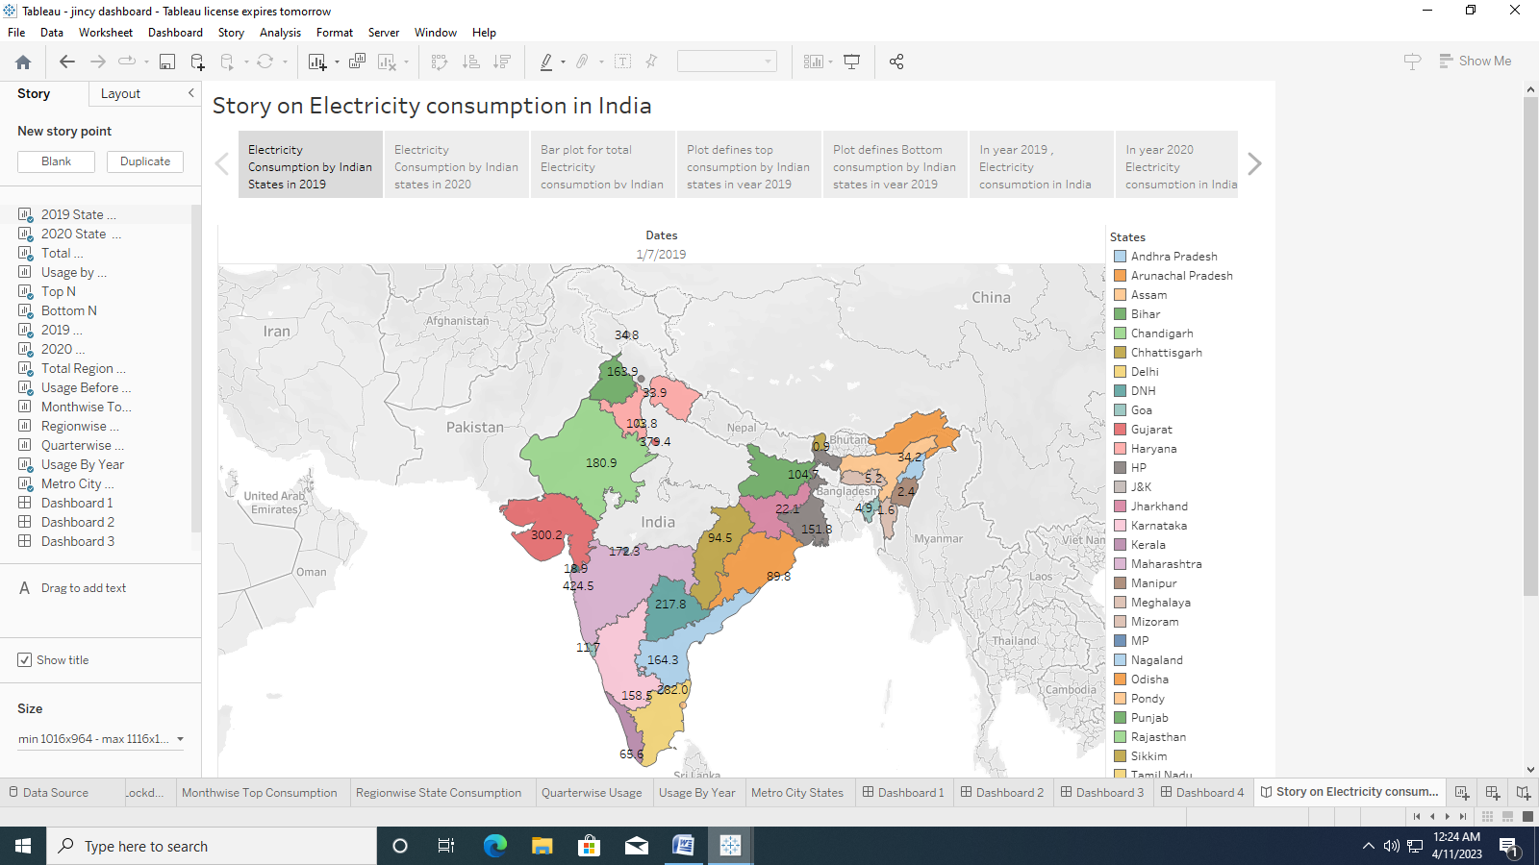

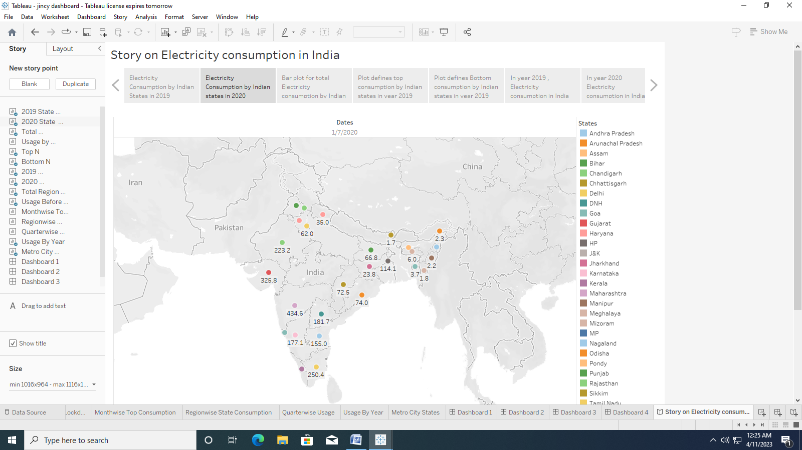

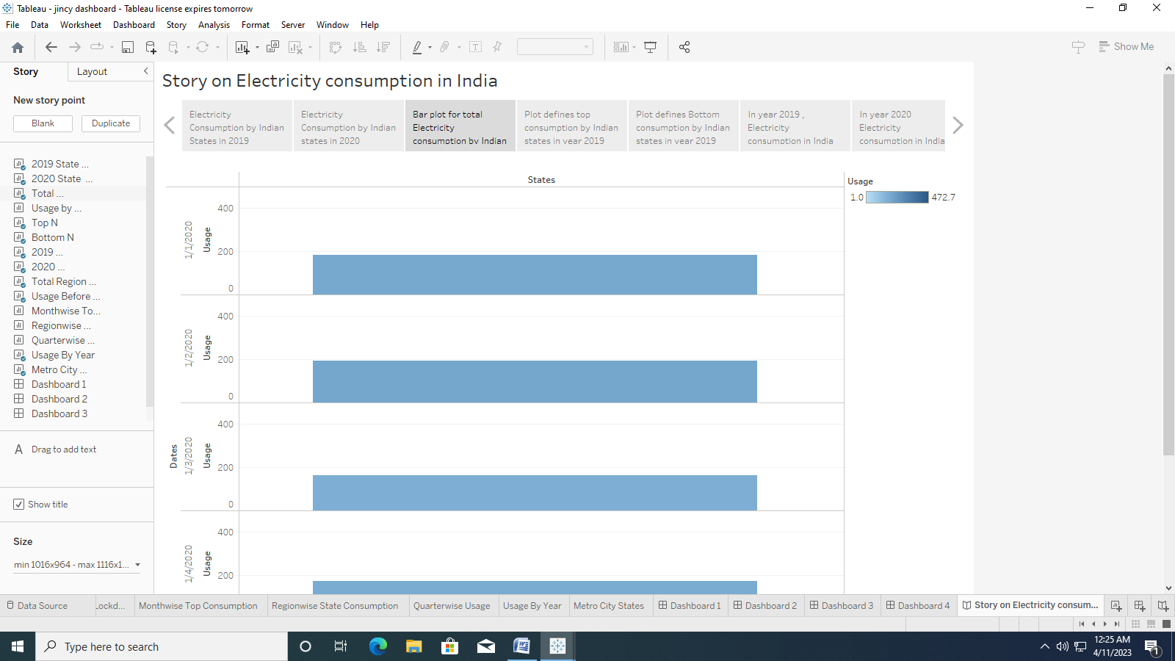

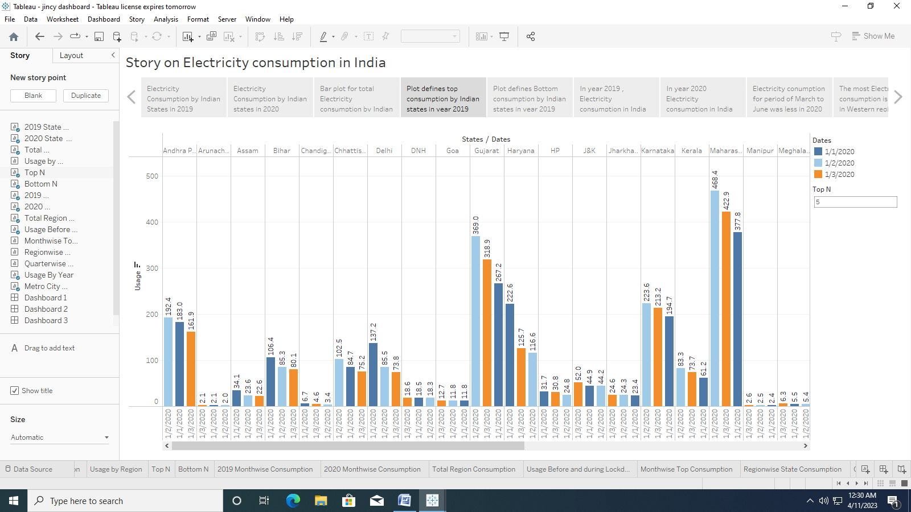

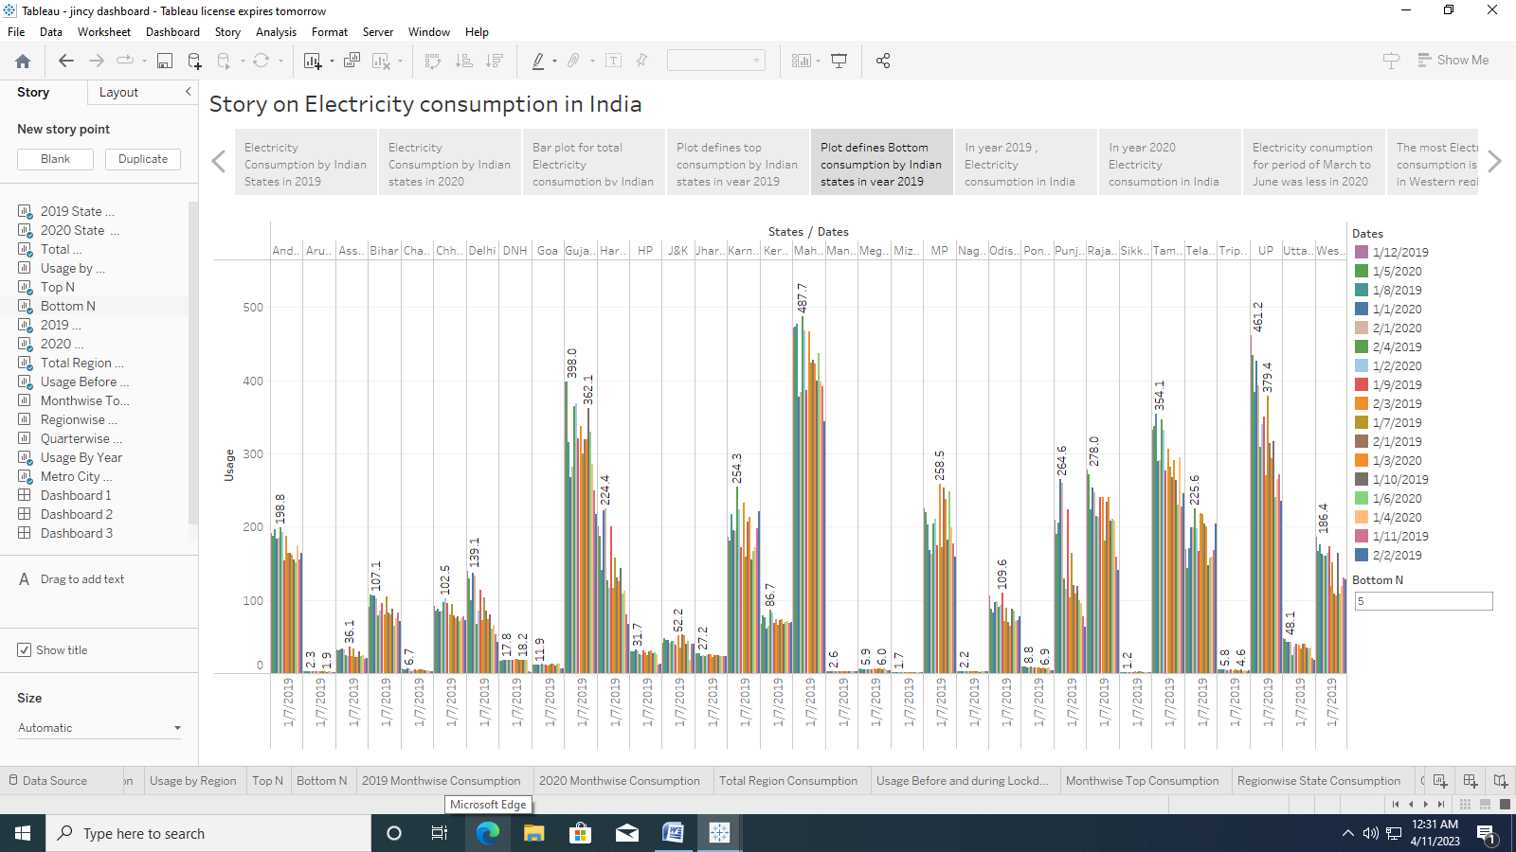

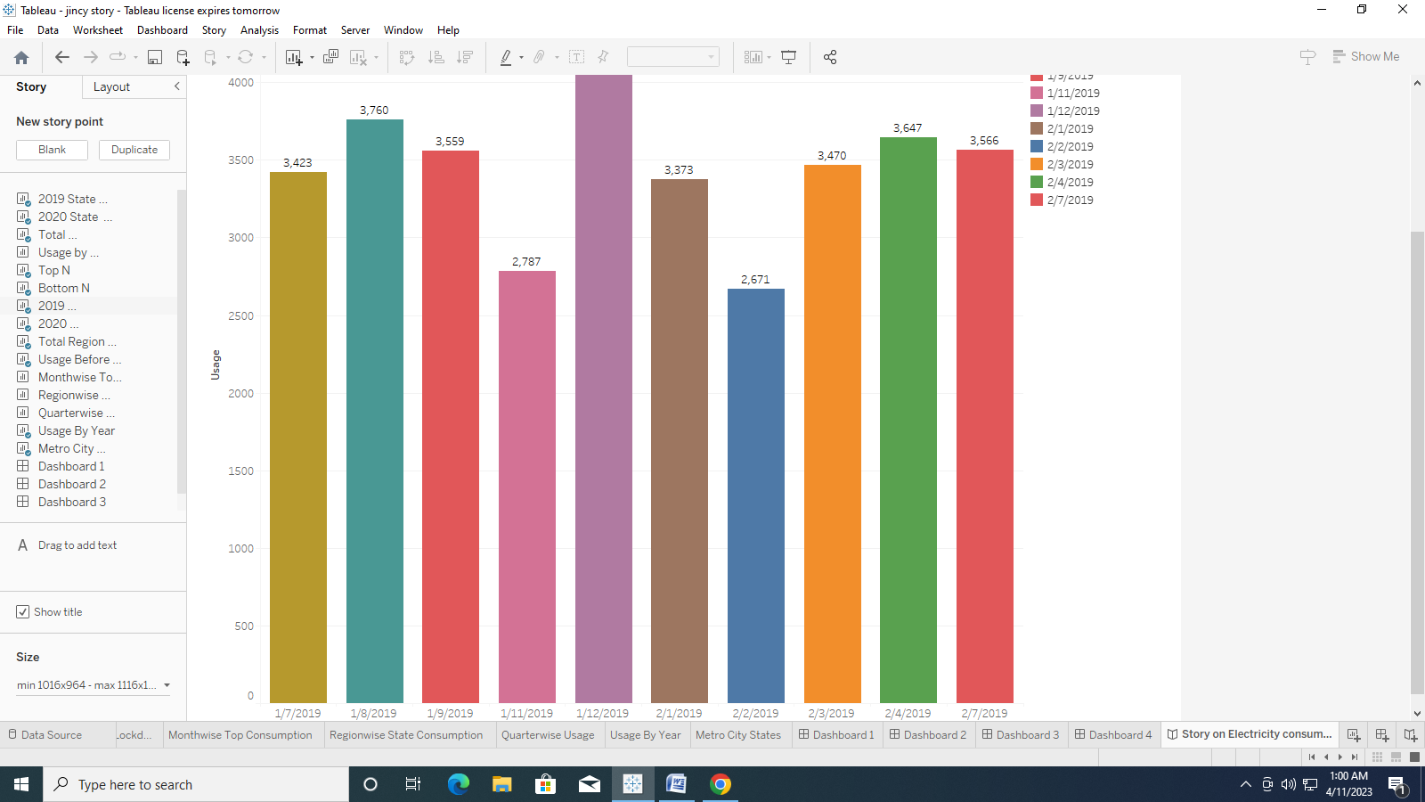

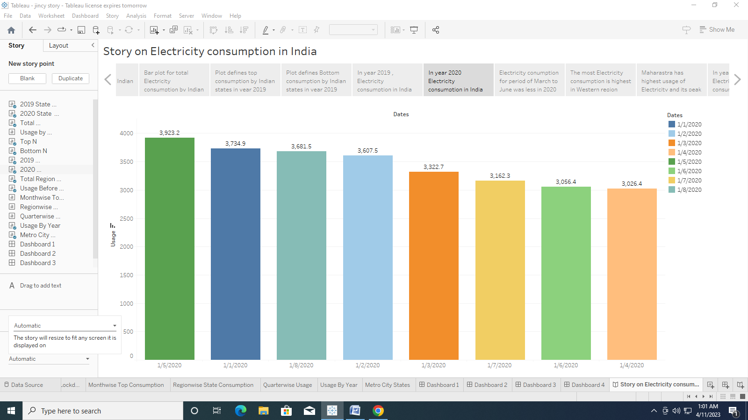

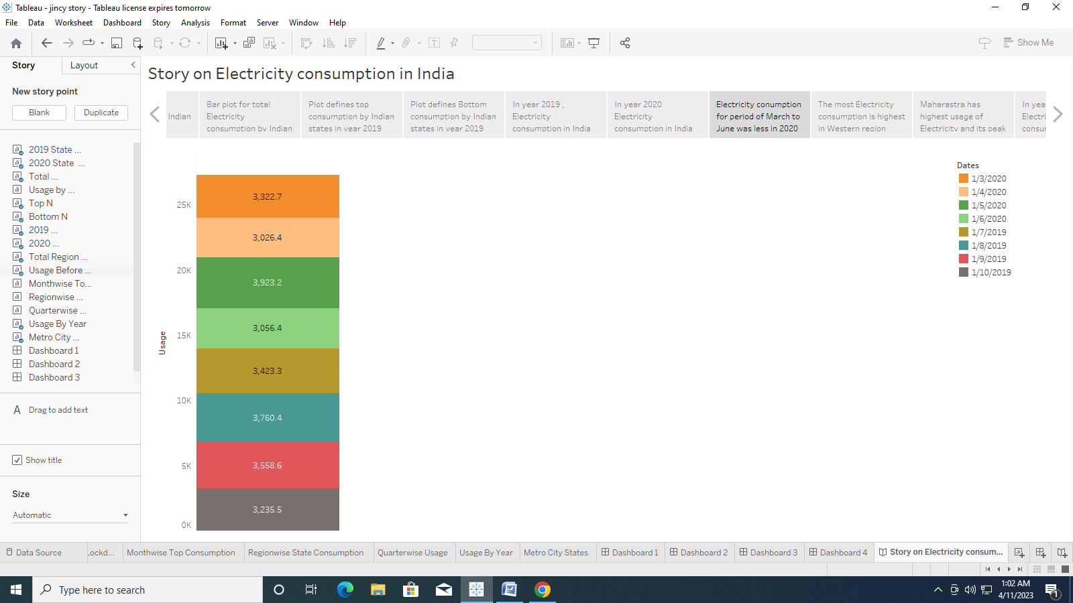

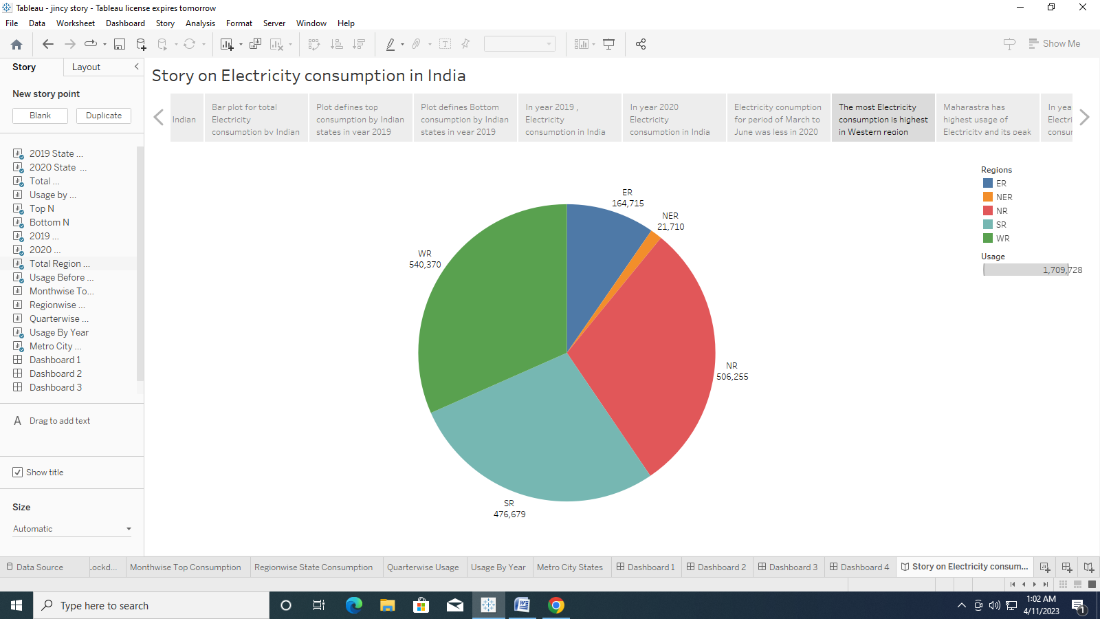

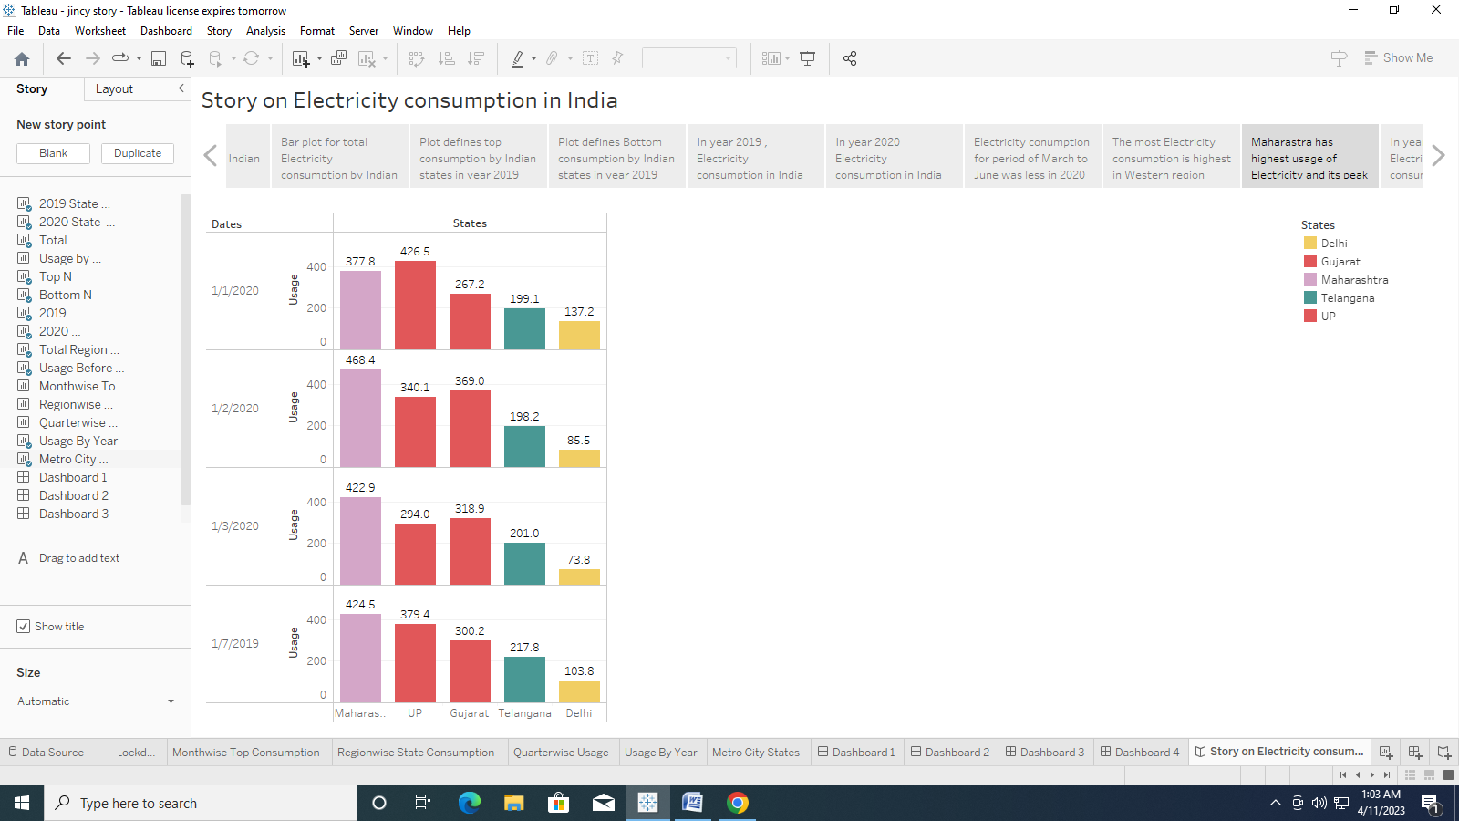

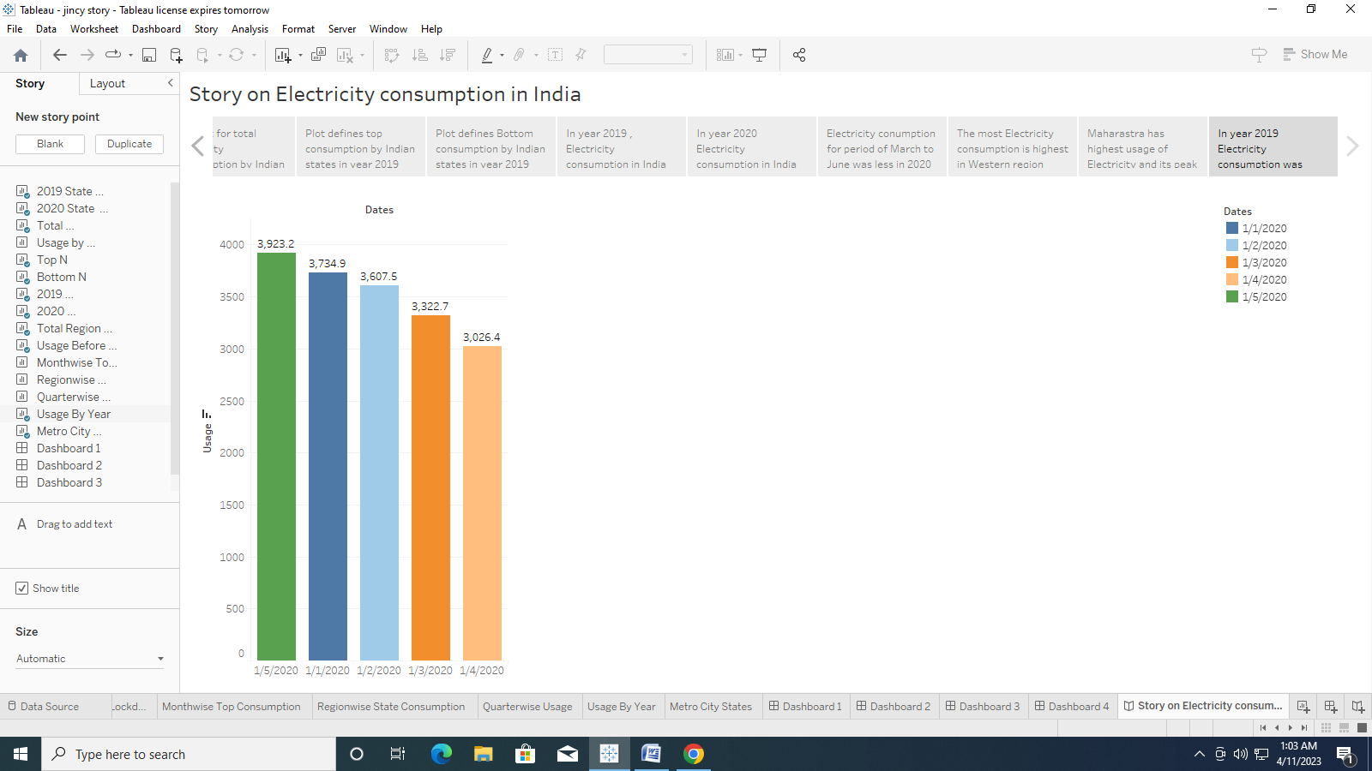

**ADVANTAGES**

*It is a clean safe, cheap and convenient source of energy.

*Lower maintenance cost

*More efficient

*It is renewable

*Reduces green house emission

*Relatively low maintenance cost

*Hydroelectric station are inexpensive to operate

**DISADVANTAGES**

*More expensive than gasoline

*Sometimes messes up wildlife

*Dependent on precipitation

*An electric vehicle is not completely emission free

*Cost for construction

*Drought can affect power production

**Applications**

1. Toasters to refrigerators, microwaves, washing machines, dishwashers, etc.
2. Entertainment
3. Health care
4. Engineering
5. Transport and Communications
6. Outdoors
7. Commercial
8. Office
9. Fuel
10. Space

**Conclusion**

Electricity is the backbone of modern society. Our life will go back to the primitive age without electricity. There is a need for rational use of electricity, as it is largely produced from non-renewable sources liked coal and water.

**Future scope**

The electricity consumption is only included for the fifteen foreground processes and raw materials, and not for clean rooms. It also can be used for making public policies and developing new marketing norms. The overall cost of integrated system fabrication if less when compare to conventional nuclear power plants.

**APPENDIX**

1. **Source code**

# Electricity Consumption Analysis